Cost Master Maintenance - List of Fields

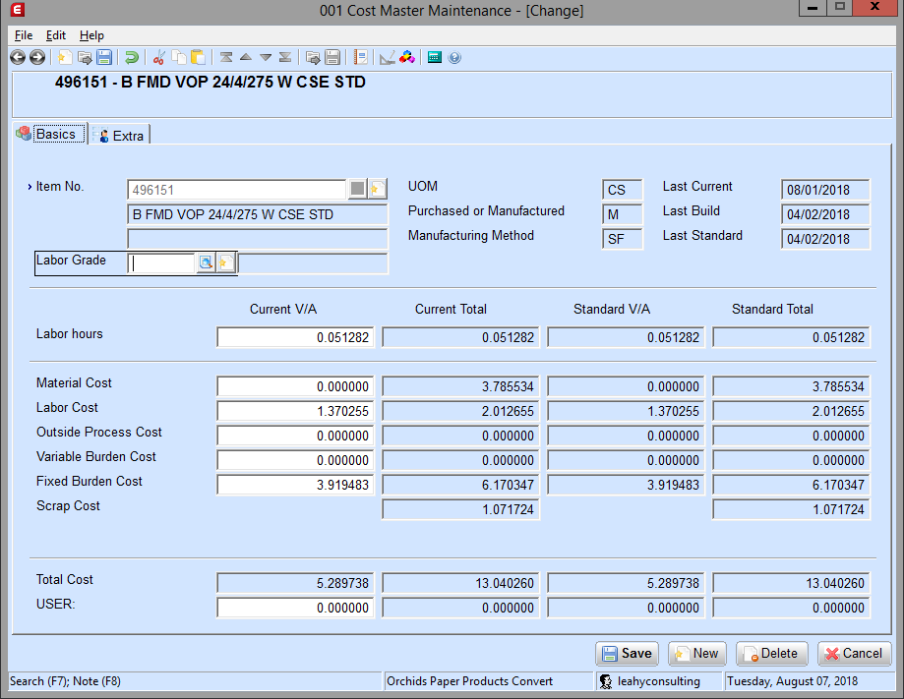
Fixed Burden, Standard Total
Description: This is the standard total cost of fixed burden for the selected item. Fixed burden is that portion of the expense indirectly connected with production that does not vary with quantity produced; examples are rent, real estate taxes, etc. This is generally zero for purchased parts. This is a display-only field.
Fixed Burden, Current Total
Description: This is the current total cost of the fixed burden for the selected item. Fixed burden is that portion of the expense indirectly connected with production that does not vary with quantity produced; examples are rent, real estate taxes, etc. This is generally zero for purchased parts. This is a display-only field.
Fixed Burden, Current V/A
Description: This is the current value added fixed burden for the selected item. When you run the Recalc V/A Costs from SPR application, S/C enters the current value added fixed burden for manufactured items. When you run the Recalc V/A Cost from POP application, S/C enters the current value added fixed burden for purchased items. When you run the Roll to Material Cost application, S/C zeros out this field for items with a manufacturing method of OE.
Enter or change the current value added fixed burden for this item. Current, in this case, means values being set up for the next annual standardization for the item. Value added, in this case, means these are costs only at this assembly level and do not include costs from lower levels of the bill of materials. Fixed burden is that portion of the expense indirectly connected with production that does not vary with quantity produced; examples are rent, real estate taxes, etc. This is generally zero for purchased parts.
Fixed Burden, Standard V/A
Description: This field shows the standard value added figure. Standard figures are figures used as standards for the current year. This value can be positive or negative. This is a display-only field.

S/C treats any Cost Master records containing an item not in the Inventory Item table as a manufactured item with a manufacturing method of SF (for Shop Floor Control). This allows you to estimate costs for items not yet in the Inventory Item table.
When you run the Create Cost Master application, S/C adds items to the Cost Master table.
Description: Enter the labor grade for S/C to calculate the value added labor cost for this item. If you leave this field blank, the recalculate V/A labor from cost master application recalculates the current value added labor cost based on the labor grades for each operation in the routing. If no routing exists and this field is left blank, the system will not be able to determine the current value added labor cost for this item.
Integration: The Recalculate V/A Labor from Cost Master application uses the current labor grade for this labor grade and the labor hours figure to calculate the current value added labor cost for the item.
Labor Grade Description (unlabeled)
Description: This is a description of the selected labor grade. Descriptions come from the Labor Grade Maintenance application. This is a display-only field.
Landed Cost, Current Total
Description: This is the current total of the landed cost. This is a display-only field.
Integration: This field is hidden if the Landed Costs check box is cleared on the Inventory Management Setup screen.
Landed Cost, Current V/A
Description: Enter the current value added landed cost for this item. Current, in this case, means values being set up for the next annual standardization for the item. Value added, in this case, means these are costs only at this assembly level and do not include costs from lower levels of the bill of materials.
Integration: This field is hidden if the Landed Costs check box is cleared on the Inventory Management Setup screen. S/C uses this to track landed costs for purchased items. If in Purchase Order, a landed cost is marked to be included in the unit cost, S/C does not duplicate the cost here. If however, the landed cost is not included in the unit cost of an item, it can be stored here during the Roll Cost application. Landed Cost would normally be entered for purchased parts that would have no lower level material costs. Landed costs for items not included in SC could be entered as Value Added Material Costs for each parent in which it resides. But it is normally better just to include the item in SC. If entered manually, this cost is typically only entered for purchased items (Purchased or Manufactured field is P).
Landed Cost, Standard Total
Description: This is the standard total of the landed cost. This is a display-only field.
Integration: This field is hidden if the Landed Costs check box is cleared on the Inventory Management Setup screen.
Landed Cost, Standard V/A
Description: This field shows the standard value added figure. Standard figures are figures used as standards for the current year. This value can be positive or negative. This is a display-only field.
Integration: This field is hidden if the Landed Costs check box is cleared on the Inventory Management Setup screen.
Last Build
Description: S/C maintains and displays the last date you ran a cost build-up to recalculate the current total costs for this item. This is a display only field.
Integration: S/C updates this field after you run the Cost Build-Up application on current costs.
Last Current
Description: S/C maintains and displays the last date the cost master was updated. This is a display only field.
Last Standard
Description: S/C maintains and displays the last date you set the standard value added and standard total figures for this item to the corresponding current figures. This is a display only field.
Integration: S/C updates this field after you run the Current to Standard Roll, Roll Selected Cost Master application.
Labor Cost, Current Total
Description: This is the current total of the labor costs. This value can be positive or negative. This is a display-only field.
Labor Cost, Current V/A
Description: Enter the current value added cost of labor for this item. Current, in this case, means values being set up for the next annual standardization for the item. Value added, in this case, means these are costs only at this assembly level and do not include costs from lower levels of the bill of materials. Labor cost is the amount of labor costs for this item at this level of the bill of material. This is generally zero for purchased parts. For items manufactured in the Production Order Processing (POP) package, this cost corresponds to Value Added Costs entered in POP with Cost Class "L". Normally, you would not manually enter this cost class here.
Labor Cost, Standard Total
Description: This is the standard total of the labor costs. This value can be positive or negative. This is a display-only field.
Labor Cost, Standard V/A
Description: This is the standard value added labor cost. Standard figures are figures used as standards for the current year. This value can be positive or negative. This is a display-only field.
Labor Hours, Current Total
Description: This is the current total of reported labor hours. This value can be positive or negative. This is a display-only field.
Labor Hours, Current V/A
Description: Enter or change the number of hours required to produce each item. Labor hours are usually zero for purchased parts and for parts manufactured in the Production Order Processing package.
Labor Hours, Standard Total
Description: This is the standard total of labor hours. This value can be positive or negative. This is a display-only field.
Labor Hours, Standard V/A
Description: This field shows the standard value added figure. Standard figures are figures used as standards for the current year. This value can be positive or negative. This is a display-only field.
Material Cost, Current Total
Description: This is the current total of reported material costs. This value can be positive or negative. This is a display-only field.
Material Cost, Current V/A
Description: Enter or change the current value added cost of the material for this item. If you run the Roll to Material Cost application, S/C copies the average, last, or standard cost from the inventory item location table and places the value here for items with a manufacturing method of OE.
Current, in this case, means values being set up for the next annual standardization for the item. Value added, in this case, means these are costs only at this assembly level and do not include costs from lower levels of the bill of materials. Material costs are the direct material cost added at that level of the product structure in the manufacture of the item. You will normally enter current value added material cost only for purchased parts that would have no lower level material costs. You can enter material cost for items not included in Standard Costing (S/C) as value added material costs for each parent in which it resides. However, it is normally better to include the item in S/C.
Material Cost, Standard Total
Description: This is the standard total of material costs. This value can be positive or negative. This is a display-only field.
Material Cost, Standard V/A
Description: This field shows the standard value added figure. Standard figures are figures used as standards for the current year. This value can be positive or negative. This is a display-only field.
Manufacturing Method
Description: This field shows the item's manufacturing method code:
OE = Order Entry
PP = Production Order Processing
SF = Shop Floor Control
S/C copies this value from the Inventory Item table when you run the Create Cost Master application. S/C updates items with a manufacturing method of PP (Production Order Processing) when you run the Recalc V/A Cost from POP application.
This is a display-only field.
Outside Process Cost, Current Total
Description: This is the current total of reported outside processing costs. This value can be positive or negative. This is a display-only field.
Outside Process Cost, Current V/A
Description: Enter or change the current value added outside processing cost for this item. Current, in this case, means values being set up for the next annual standardization for the item. Value added, in this case, means these are costs only at this assembly level and do not include costs from lower levels of the bill of materials. This is the cost for outside processing operations such as plating, painting, heat treating, etc. that would occur while directly creating this item. For example, if a routing exists to create this item that includes plating at a step by an outside vendor, then you would enter the cost of that plating here.
Outside Process Cost, Standard Total
Description: This is the standard total of outside processing costs. This value can be positive or negative. This is a display-only field.
Outside Process Cost, Standard V/A
Description: This field shows the standard value added figure. Standard figures are figures used as standards for the current year. This value can be positive or negative. This is a display-only field.
Purchased or Manufactured
Description: This field shows if the item is purchased (P) or manufactured (M). This is a display-only field.
Integration: This value is set in the Item Master Maintenance application in Inventory Management.
Scrap Cost, Current Total
Description: This is the sum of all scrap costs accumulated throughout the product structure of this item, if it is a manufactured item. This cost is based on the scrap factor stored for each component in the product structure used to build this item times the current total material cost of each component item. It can also include the impact of fixed scrap quantities stored for each component in the product structure. This value can be positive or negative. This is a display-only field.
Scrap Cost, Standard Total
Description: This is the standard total of scrap costs. This value can be positive or negative. This is a display-only field.
Total, Current Total
Description: This is the sum of the Current Total column: Material Cost, Labor Cost, Outside Process Cost, Variable Burden Cost, Fixed Burden Cost, and Landed Cost. S/C updates this total when values in the Current Total column change. This value can be positive or negative. This is a display-only field.
Total, Current V/A
Description: This field displays the sum of the Current V/A column: Material Cost, Labor Cost, Outside Process Cost, Variable Burden Cost, Fixed Burden Cost, and Landed Cost. S/C updates this total when values in the Current V/A column change. This value can be positive or negative. This is a display-only field.
Total, Standard Total
Description: This field displays the sum of the Standard Total column: Material Cost, Labor Cost, Outside Process Cost, Variable Burden Cost, Fixed Burden Cost, and Landed Cost. S/C updates this total when values in the Standard Total column change. This value can be positive or negative. This is a display-only field.
Total, Standard V/A
Description: This field displays the sum of the Standard V/A column: Material Cost, Labor Cost, Outside Process Cost, Variable Burden Cost, Fixed Burden Cost, and Landed Cost. S/C updates this total when values in the Standard V/A column change. This value can be positive or negative. This is a display-only field.
UOM
Description: This is the unit of measure for the selected item. If this field has no value in it, either the selected item is not in the Item Master table, or the unit of measure has not been defined for this item. This is a display-only field.
Integration: A value in this field comes from the Item Master Maintenance application in Inventory Management.
User Defined Field, Current Total
Description: This is the current total of the reported quantity or cost you are tracking. This value can be positive or negative. This is a display-only field.
The user defined cost field is an additional cost accumulator that allows you to track another cost field. For example, it could keep track of weight or freight charges. This field is defined on the Standard Costing Setup screen. Costs for the user-defined field are rolled up during the Cost Build up process, but not included in the item total actual cost.
Integration: S/C does not display this field unless the Display User Defined Field? check box is selected on the Standard Costing Setup screen.
User Defined Field, Current V/A
Size: 7.6
Type: Signed
Description: Enter or change the current value added figure for the amount you are tracking. This value can be positive or negative.
The user defined cost field is an additional cost accumulator that allows you to track another cost field. For example, it could keep track of weight or freight charges. This field is defined on the Standard Costing Setup screen. Costs for the user-defined field are rolled up during the Cost Build up process, but not included in the item total actual cost.
Integration: S/C does not display this field unless the Display User Defined Field? check box is selected on the Standard Costing Setup screen.
User Defined Field, Standard Total
Description: This is the standard total of quantity or cost you are tracking. This value can be positive or negative. This is a display-only field.
The user defined cost field is an additional cost accumulator that allows you to track another cost field. For example, it could keep track of weight or freight charges. This field is defined on the Standard Costing Setup screen. Costs for the user-defined field are rolled up during the Cost Build up process, but not included in the item total actual cost.
Integration: S/C does not display this field unless the Display User Defined Field? check box is selected on the Standard Costing Setup screen.
User Defined Field, Standard V/A
Description: This field shows the standard value added figure. Standard figures are figures used as standards for the current year. This value can be positive or negative. This is a display-only field.
The user defined cost field is an additional cost accumulator that allows you to track another cost field. For example, it could keep track of weight or freight charges. This field is defined on the Standard Costing Setup screen. Costs for the user-defined field are rolled up during the Cost Build up process, but not included in the item total actual cost.
Integration: S/C does not display this field unless the Display User Defined Field? check box is selected on the Standard Costing Setup screen.
Var Br Dollars, Current Total
Description: This is the current total of reported variable burden costs. This value can be positive or negative. This is a display-only field.
Variable Burden Cost, Current V/A
Description: Enter or change the current value added variable burden cost for this item. When you run the Roll to Material Cost application for current costs, S/C zeros out this field for items with a manufacturing method of OE.
Current, in this case, means values being set up for the next annual standardization for the item. Value added, in this case, means these are costs only at this assembly level and do not include costs from lower levels of the bill of materials. This is the current value added variable burden at this level of the bill of material and includes indirect costs that are affected by the quantity of an item produced. This is generally zero for purchased parts.
Variable Burden Cost, Standard Total
Description: This is the standard total of variable burden costs. This value can be positive or negative. This is a display-only field.
Variable Burden Cost, Standard V/A
Description: This is the standard value added of variable burden costs. Standard figures are figures used as standards for the current year. This value can be positive or negative. This is a display-only field.

