

Macola Manufacturing set-up screens that require
general ledger account entries
(updated 6/15/19)

Note: Much of the following was copied from the Macola on-line help screen and edited for readability.

Material Cost Type/Location Account Maintenance

Material Cost Type/Location Maintenance allows tracking of inventory costs by material cost type within a particular location. If multiple locations are in use and costs are tracked within each location, simply enter a material cost type for each location code. IM Distributions to GL will be based on the cross reference of the transaction location and the material cost type of the item. If a transaction occurs in which the Material Cost Type/Location accounts are set up for the Material Cost Type at that Location, distributions will be made to those appropriate accounts.

Material Cost Type/Location Maintenance – this screen and the Work Center Account Group screen are the two screens that dictate the majority of Shop Floor Control entries.

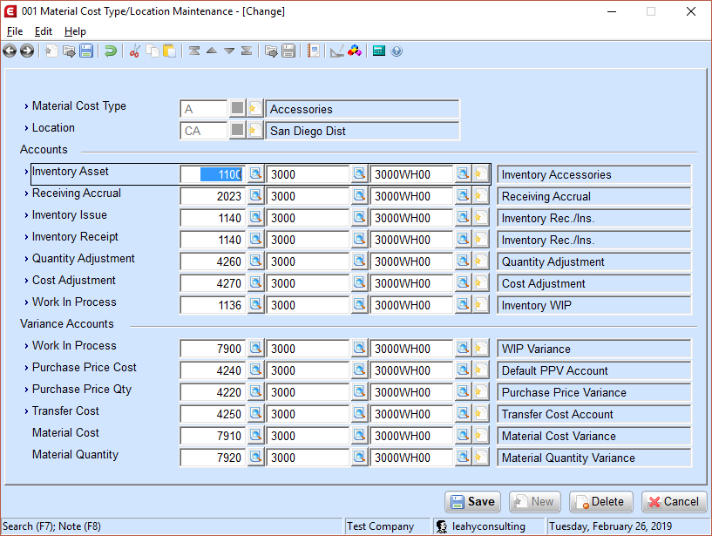

Type of Accounts

The following sections describe the individual accounts of the Material Cost Type/Location Maintenance. Along with the description, the tables within each section describe the types of transactions that will distribute to the account, the normal distribution type (debit/credit), and the offsetting account from the transaction.

Inventory Asset Account

The Inventory Asset Account represents the value of inventory, where inventory assets are posted. This account is debited as inventory is increased and credited when inventory is depleted. Types of Transactions that will distribute to the Inventory Asset Account:

Type of transaction | Normal Distribution | Offset Distribution Account
IM Trx R=Receipt | Debit | Inventory Receipt
IM Trx I=Issue | Credit | Inventory Issue
IM Trx T=Transfer | Credit From Location, Debit To Location | Asset, Transfer Cost
IM Trx C=Cost Adj | Credit Cost Decrease, Debit Cost Increase | Cost Adjustment
IM Trx Q=Qty Adj | Credit negative adj, Debit positive adj | Quantity Adjustment
IM Phys/Cycle Count | Credit negative adj, Debit positive adj | Quantity Adjustment
OE Posting Invoices | Credit (Non Confirm Pick/Ship setting) | Cost of Goods Sold
OE Credit Memos | Debit at CM entry (not from RMA) | Cost of Goods Sold
OE Confirm Pick | Credit | Pick Offset
OE Confirm Ship | Credit | Ship Offset
OE RMA Receipt | Debit | Inventory Receipt
PO Receipt | Debit | Receiving Accrual
PO Receipt (Inspection) | Debit R/I Asset | R/I Receiving Accrual
PO R/I Disposition | Credit R/I Asset, Debit Stk. or MRB asset | See * below
PO MRB Disposition | Credit MRB Asset, Debit Asset | See * below
BOM Print Costed Bill | Credit Cost Decrease, Debit Cost Increase | Cost Adjustment
POP Release Orders ¹ | Credit Asset of components | Debit WIP of parent
POP Unrelease Orders ¹ | Debit Asset of components | Credit WIP of parent
POP Report Production | Debit Asset of parent ² | Credit WIP or comp. Asset ¹
POP Disassembly | Credit Asset of parent ² | Debit Asset of component ²
POP Adjust Material Issue | Debit/Credit component based on change | WIP Variance of parent
SFC Material Issue/Return | Credit – Issue. Debit – Return ³ | Debit/Credit WIP of parent ³
SFC Online Picking | Credit component asset ³ | Debit WIP of parent ³
SFC Material Reject | Debit component asset ³ | Credit WIP of parent ³
SFC Act. Trx. – Backflush | Credit component asset – M Count Point ³ | Debit WIP of parent ³
SFC Act. Trx. – Parent | Debit parent asset – Y Count Point ³ | Credit WIP of parent ³
MCA Post Transactions | Debit/Credit parent based on quantity | Debit/Credit Material Qty **

¹ - Depends on the value of the ‘Create WIP’ setting when releasing the POP order. If Create WIP = N, then no distributions will occur at release. The component asset account will be credited at reporting production. If Create WIP = W or Y, then distributions will be made as listed.
² - Any difference between the component cost (including Value Added Costs) and the parent cost will be distributed to the WIP Variance of the parent item
³ - Distributions appear on the MCA Distributions to GL
* - Distributions will occur to multiple accounts based on the action taken during the R/I and MRB Dispositions. The receipt at PO Receiving will distribute to the R/I Asset (Debit) and the R/I Accrual (Credit). If quantities are accepted during the R/I disposition, then the R/I Asset and R/I Accrual accounts are washed into the Asset and Accrual accounts of the stocking location, respectively. If quantities are moved to the MRB location for further review, then the R/I Asset (Credit) and R/I Accrual (Debit) are washed again, but this time the opposing distributions will go to the MRB Asset (Debit) and MRB Accrual (Credit) accounts. Quantities accepted through MRB will wash the MRB Asset (Credit) and MRB Accrual (Debit) into the Asset (Debit) and Accrual (Credit) of the stocking location, similar to accepting quantity at the R/I location. Other actions taken during the R/I or MRB Dispositions, such as Scrap, Destroy, and Return To Vendor, will result in appropriate distributions being made to each respective account as defined on page two of the Inventory Location Maintenance.
**- In an average cost environment and Posting the MCA Transaction for the closing of a shop order, a remaining variance will post to the inventory asset account if the quantity on hand in the item location is greater than the completed quantity.

Receiving Accrual Account

The Receiving Accrual Account is credited when items are received from purchase orders until a voucher from the vendor is received. The Receiving Accrual offsets the distribution to the Inventory Asset account at PO receiving. This account is then washed by the Accounts Payable account when a voucher is processed against it.

Note: This account is captured on the Purchase Order line item from the Material Cost Type/Location maintenance. A change made to the Receiving Accrual Account in Material Cost Type/Location maintenance will not automatically update existing purchase orders. Types of Transactions that will distribute to the Receiving Accrual Account:

Type of transaction | Normal Distribution | Offset Distribution Account
PO Receiving | Credit | Inv Asset, PPV Suspense*
AP Vouchering | Debit | A/P, PPV Qty and Cost*

* - Distribution will vary depending on the Inventory Cost Method in IM Setup. PPV Suspense (from PO Setup) is only used in a Standard Cost Environment. A PPV Suspense distribution will occur for the difference between the Receipt Cost and the cost on file in the Item Location. A PO Receipt/AP Voucher in which all costs are equal will Debit the Inventory Asset and Credit the Receiving Accrual at PO Receipt. At AP Vouchering, the Receiving Accrual is debited and the Account Payable account is credited. See the PPV Cost and PPV Quantity sections for further details concerning the PPV accounts.

Inventory Issue Account

The Inventory Issue Account is debited when a miscellaneous issue transaction is generated through the Enter Inventory Transactions screen in IM. The Inventory Asset account receives the credit from this transaction. Types of Transactions that will distribute to the Inventory Issue Account:

Type of transaction | Normal Distribution | Offset Distribution Account
IM Trx I=Issue | Debit | Inventory Asset

Inventory Receipt Account

The Inventory Receipt Account is credited when a miscellaneous receipt transaction is generated through the Enter Inventory Transactions screen in IM or through RMA Receiving in OE. The Inventory Asset account receives a debit from this transaction. Types of Transactions that will distribute to the Inventory Receipt Account:

Type of transaction | Normal Distribution | Offset Distribution Account
IM Trx R=Receipt | Credit | Inventory Asset
OE RMA Receipt | Credit | Inventory Asset

Quantity Adjustment Account

The Quantity Adjustment Account is debited or credited when quantities are changed due to physical counts or IM adjustment transactions, for the cost of parts times the number adjusted. Debit or credit is determined by the direction of the adjustment (increase or decrease). The offsetting entry (debit or credit) of this account posts to the Inventory Asset account. Types of Transactions that will distribute to the Quantity Adjustment Account:

Type of transaction | Normal Distribution | Offset Distribution Account
IM Trx Q=Quantity Adj | Debit negative adj, Credit positive adj | Inventory Asset
IM Physical/Cycle Count | Debit negative adj, Credit positive adj | Inventory Asset

Cost Adjustment Account

The Cost Adjustment Account is debited or credited when the cost of an inventory item changes. C=Cost Adjustment type transactions in Inventory Management, the Print Costed Bill process in Bill of Material, and the Roll Select Cost Master process in the Standard Costing modules will result in overall change in the inventory value of the item. These make it necessary for distributions to the Inventory Asset account and the Cost Adjustment Account. Types of Transactions that will distribute to the Cost Adjustment Account:

Type of transaction | Normal Distribution | Offset Distribution Account
IM Trx C=Cost Adj | Debit reduced cost, Credit increased cost | Inventory Asset
BOM Print Costed Bill | Debit reduced cost, Credit increased cost | Inventory Asset
SC Roll Select Cost Master | Debit reduced cost, Credit increased cost | Inventory Asset

Work In Process (WIP) Account

The Work In Process (WIP) Account holds the value of the material, labor, and absorbed costs issued to the manufacturing order when these items are manufactured. Types of Transactions that will distribute to the Work In Process Account:

Type of transaction | Normal Distribution | Offset Distribution Account
POP Release Orders ¹ | Debit WIP of parent | Credit Asset of components
POP Unrelease Orders ¹ | Credit WIP of parent | Debit Asset of components
POP Report Production | Credit WIP ¹ ² | Debit Asset of parent ²
SFC Material Issue | Debit WIP of parent ³ | Credit Asset of component ³
SFC Material Return | Credit WIP of parent ³ | Debit Asset of component ³
SFC Online Picking | Debit WIP of parent ³ | Credit component asset ³
SFC Material Reject | Credit WIP of parent ³ | Debit component asset ³
SFC Act. Trx. – Backflush | Debit WIP of parent – M Count Point ³ | Credit component asset ³
SFC Act. Trx. – Parent | Credit WIP of parent – Y Count Point ³ | Debit parent asset ³
MCA Post Transactions | Debit/Credit depending on variance | Dependent of cost method *

¹ - Depends on the value of the ‘Create WIP’ setting when releasing the POP order. If Create WIP = N, then no distributions will occur at release. The component asset account will be credited at reporting production. If Create WIP = W or Y, then distributions will be made as listed.
² - Any difference between the component cost (including Value Added Costs) and the parent cost will be distributed to the WIP Variance of the parent item
³ - Distributions appear on the MCA Distributions to GL
* - In most cases in an average cost environment, remaining WIP will be posted to the Inventory Asset Account. In a standard cost environment, remaining WIP will be posted to the WIP Variance account.

Work In Process (WIP) Variance Account

Distributions are posted to this account if manufacturing costs differ from the cost of the parent. Types of Transactions that will distribute to the WIP Variance Account:

Type of transaction | Normal Distribution | Offset Distribution Account
POP Complete Production | Debit/Credit WIP Variance ¹ | Debit parent asset, Credit WIP ¹
POP Disassembly | Debit/Credit WIP Variance ² | Credit parent, Debit Component²
MCA Post Transactions | Debit/Credit WIP Variance ³ | Debit/Credit WIP ³
MCA Std Cost Distribution | Debit/Credit WIP Variance * | Debit/Credit based on source *

¹ - Depends on the value of the ‘Create WIP’ setting when releasing the POP order. If Create WIP = N, then no distributions will occur at release. The component asset account will be credited at reporting production. If Create WIP = W or Y, then distributions will be made as listed.
² - Any difference between the component cost (including Value Added Costs) and the parent cost will be distributed to the WIP Variance of the parent item
³ - In a standard cost environment, remaining WIP will be posted to the WIP Variance account.
* - Splits out the remaining WIP Variance based on the source of the variance. This can include, but not limited to, distributions to Material Cost Account, Material Quantity Account, and Labor Variance.

PPV Cost Account

Using Standard cost method, the Purchase Price Variance (PPV) Cost Account is used by the A/P package to accumulate differences between the dollars invoiced versus the item’s standard cost. When using Average, Last, LIFO, or FIFO Cost Methods, this is the dollars invoiced versus the receipt cost. The PPV Cost will represent the dollar amount difference between the Receiving Accrual account and the Accounts Payable account when vouchered.

Note: This account is captured on the Purchase Order line item from the Material Cost Type/Location maintenance. A change made to the PPV Cost Accounts in Material Cost Type/Location maintenance will not update existing purchase orders. Types of Transactions that will distribute to the PPV Cost Account:

Type of transaction | Normal Distribution | Offset Distribution Account
AP Vouchering | Debit/Credit PPV Cost Account ¹ | Accounts Payable Account ¹

¹ - The receiving accrual is always debited for the entire amount against the PO line item. The Accounts Payable Account is credited for the entire dollar amount vouchered. PPV Cost will be debited if the dollar amount vouchered against the PO line item is greater than the amount in Receiving Accrual. PPV Cost will be credited if the dollar amount vouchered against the PO line item is less than the amount in the Receiving Accrual.

PPV Quantity Account

The Purchase Price Variance (PPV) Quantity Account is used by the A/P package to accumulate any difference between the quantity received versus the quantity invoiced. This account will be used when the voucher quantity entered (on page two of A/P - Enter Voucher Transactions) is greater than the PO receipt quantity and the PO line item is invoiced in full. For example, a PO line item is received for a quantity of 10 at a cost of $8 (same as cost in the Item Location). However, the line item is vouchered for a quantity of 12 at a cost of $8 each. The A/P account will be credited for $96. The Receiving Accrual will be debited for $80. The PPV Quantity will be debited for the difference, $16.
PPV Quantity will not receive distributions if the voucher quantity is less than the PO receipt quantity. This difference in quantity will remain as received but not invoiced.

Note: This account is captured on the Purchase Order line item from the Material Cost Type/Location maintenance. A change made to the PPV Quantity Accounts in Material Cost Type/Location maintenance will not update existing purchase orders. Types of Transactions that will distribute to the PPV Quantity Account:

Type of transaction | Normal Distribution | Offset Distribution Account
AP Vouchering | Debit | Credit A/P, Debit Accrual

Transfer Cost Account

The Transfer Costs Account is debited or credited for the difference of standard costs at different locations. Any change in value for parts moved between locations is written to this account. The Transfer Cost Account for the FROM location will be debited or credited based on the difference between item location costs. For example, an item has a cost of $3 at location AA and a cost of $3.50 at location BB. If a quantity of 100 is transferred from location AA to location BB, then the following distributions occur:

The Inventory Asset for location AA is credited for $300.00
The Inventory Asset for location BB is debited for $300.00
The Inventory Asset for location BB is debited again for $50.00
The Transfer Cost Account for location AA is credited for $50.00

Types of Transactions that will distribute to the Transfer Cost Account:

IM T=Transfer type transactions

Type of transaction | Normal Distribution | Offset Distribution Account
IM Trx T=Transfer | Debit or Credit FROM Location | Credit FROM asset, Debit TO asset

Material Cost Account

Used only by the Standard Cost Distribution application in MCA when a shop order is closed. Creates variance distributions for the account based on the difference between actual costs incurred on the shop order and the planned costs based on the shop order. Types of Transactions that will distribute to the Material Cost Account:

Type of transaction | Normal Distribution | Offset Distribution Account
MCA Standard Cost Dist. | Debit/Credit | WIP Variance

Material Quantity Account

Used only by the Standard Cost Distribution application in MCA when a shop order is closed. Creates variance distributions for this account based on the difference between the actual quantity on the shop order and the planned quantity based on the shop order. Types of Transactions that will distribute to the Material Quantity Account:

Type of transaction | Normal Distribution | Offset Distribution Account
MCA Standard Cost Dist. | Debit/Credit | WIP Variance

Product Category/Location Account Screen – this screen dictates the account to be used when customer invoices are posted.

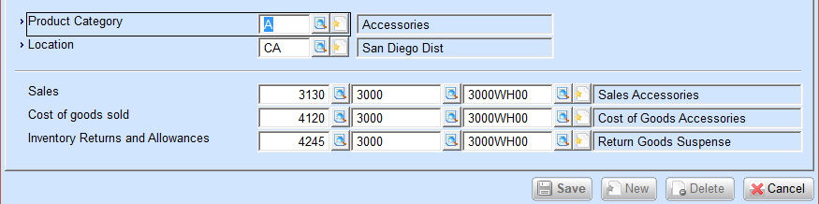

Order Entry setup screen - this screen dictates the default accounts to be used if a Product Category and Location combination is not found in the Product Category/Location Account screen. These accounts should be set to a ‘99999’ account to detect setup errors in your item master file.

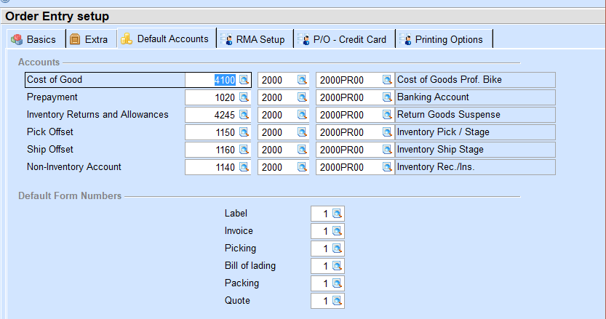

Inventory Management setup screen - this screen dictates the default accounts to be used if a valid Material Cost Type and Location combination records is not found. These accounts should be set to a ‘99999’ account to detect setup errors in your item master file.

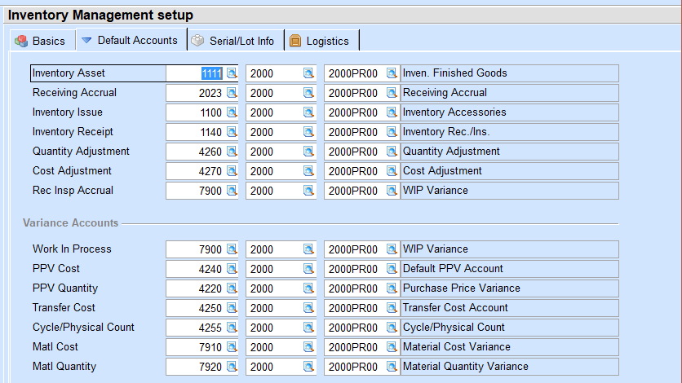

Accounts Receivable setup screen - this screen dictates the default accounts to be used if a valid customer type screen is not found. These accounts should be set to a ‘99999’ account to detect setup errors in your item master file.

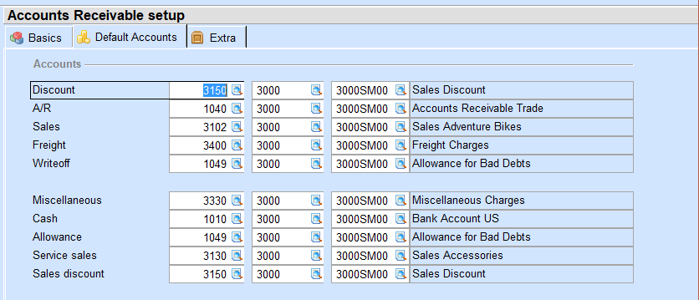

Manufacturing Setup - this screen dictates the accounts to be used for each Shop Order.

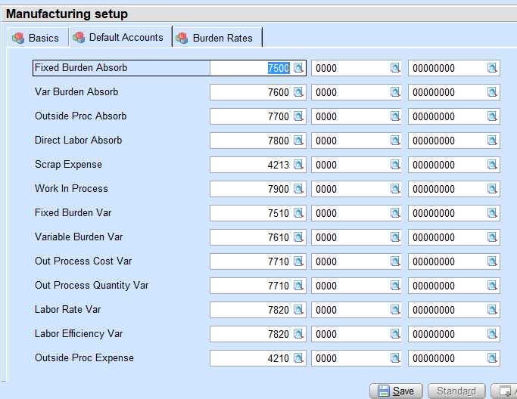

Work Center Account Group – This is only used by Shop Floor Control users. The screen dictates the accounts to be used for each Department and Work Center record. This screen is very important as it dictates all Shop Floor absorbion and variance accounts.

